**Department of Information Systems and Cyber Security University of Texas in San Antonio**



IS 3413: Telecom and Networking-001, Fall, 2022

Name: Daniel Cook  
UTSA ID: dhz799  
Email address: *danielwcook5@gmail.com*

Lab Assignment: Lab: M07 – Network Redesign RFP  
Date Due: 10/15/2022  
Date Submitted: 10/15/2022

Section A, Question 1:

What additional information should be part of Ashley’s Needs Analysis?

Vendors may encourage switching the current switch with a high-speed switch for gigabyte internet. Printers, anti-virus software and security, Power supply, and servers could be added. File server and mail server may be encouraged as well. 20 new workstations are encouraged, vendors may suggest Adobe photoshop instead of CorelDraw. Estimated 23 MS Office.

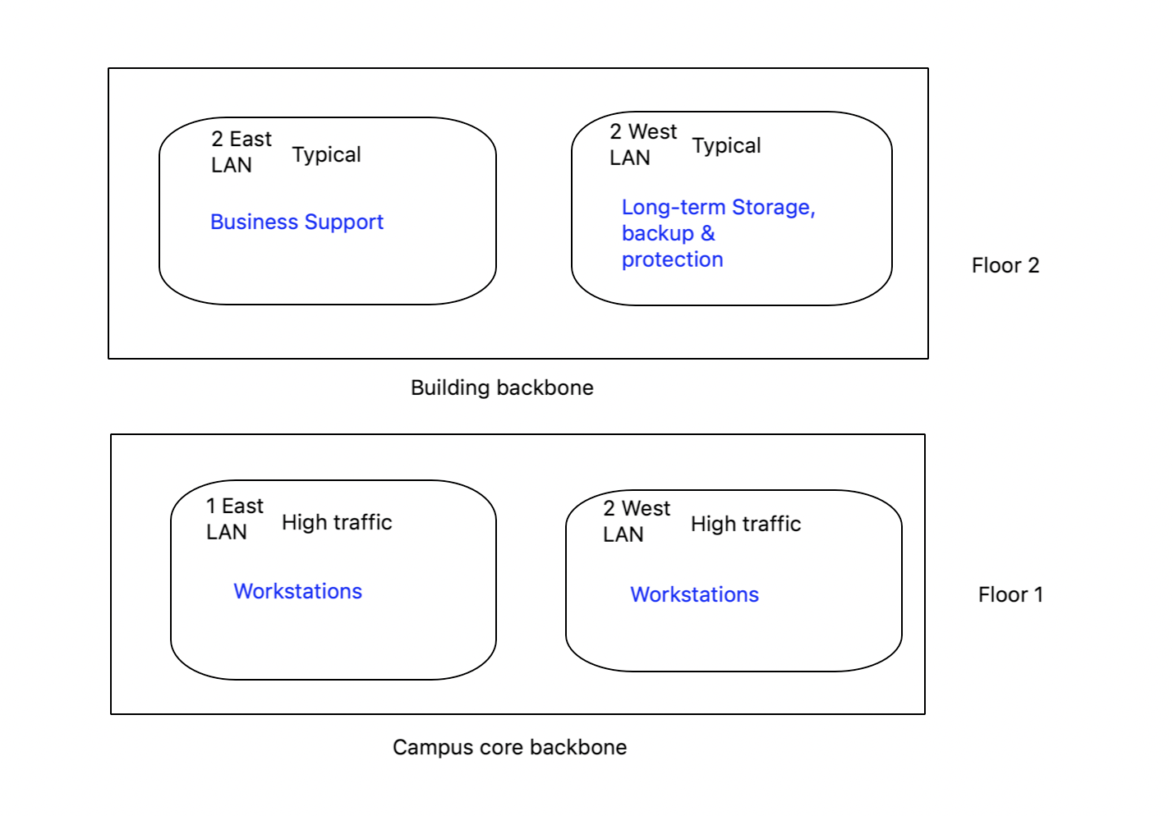

Mandatory: File server, Mail server & Web server

Wishlist:

Digital Art Workstations for 8-10 illustrators (currently 4 aging, but acceptable PCs) (1 east & 1 west)

Digital Art Software for 8-10 illustrators (currently 2 registered copies of CorelDraw 2018) (1 east & 1 west)

3-4 Workstations for Business Support (Contracts/Legal, Sales, Human Resources, etc.) (2 east)

Business Support software (Currently 1 copy of MS Office 2016) (floor 1 & 2)

Long-term storage and backup for digital art designs (2 west)

Storage and protection of sensitive business and personnel data (2 west)

Digital Artist ready access to Internet resources and collaboration with each other (floor 1 & 2)

Ability to connect wirelessly to network for visiting artists and field laptops/tablets (floor 1 & 2)

VOIP capability for entire office (floor 1 & 2)

Web Server to display and advertise designs (2 west)

Gigabit fiber optic connectivity throughout (floor 1 & 2)

Section A, Question 2:

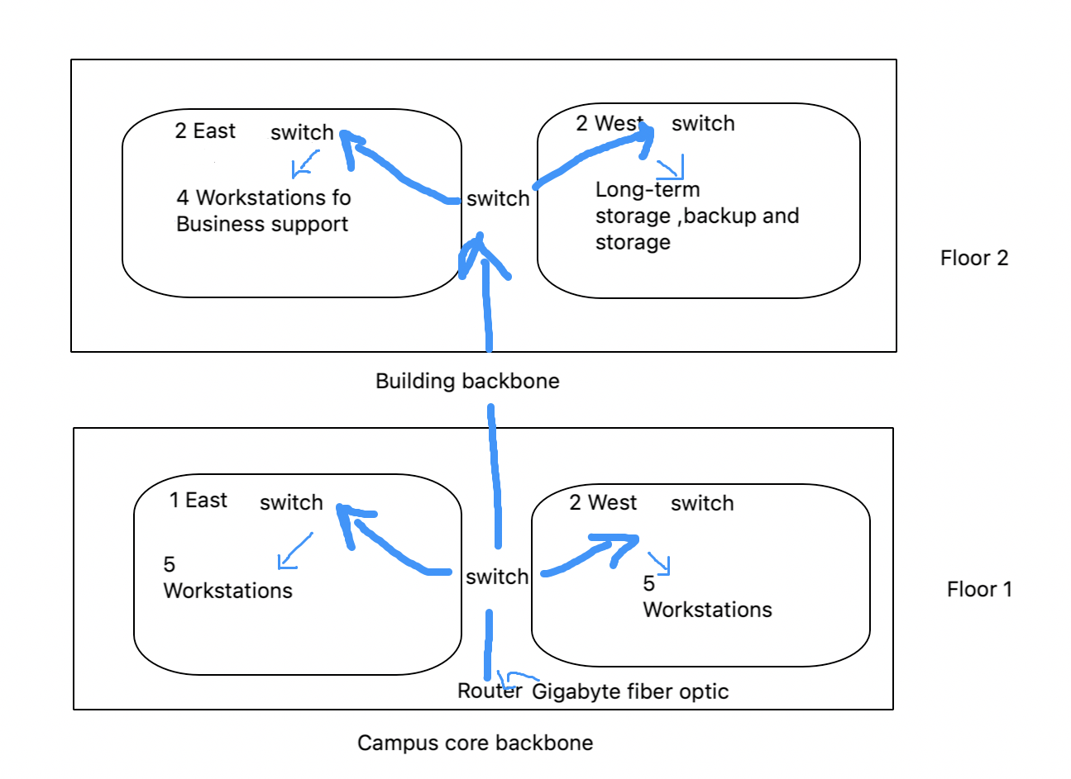

First goes the internet, which is a gigabyte fiber optic, then the router that flows through the floors that go through the area of workstations, storage, and backups.

Section A, Question 3:

RFP Proposal

* Background Information
  + Ashley’s Artistic Designs
  + Gigabyte Optic Fiber Internet
  + Powerful internet that can handle traffic
* Network Requirements
  + 14 workstations, server, laptops, telephones
  + File server, web server & mail server.
  + Firewall
* Service requirements
  + Copies of CorelDraw, business support software
* Bidding Process
  + 8 AM – 8 PM
  + No food or drinks
  + Strict
* Information required from vendor
  + Microsoft
  + Company
  + Switches, routers and computers, etc.
  + One of the largest backbone networks in the world